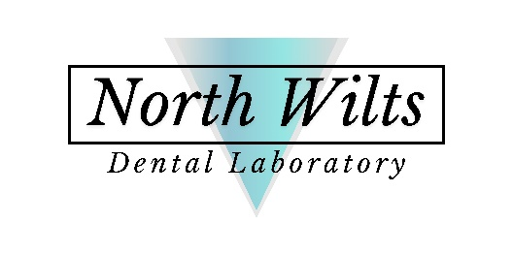
North Wilts
Dental Laboratory

Abbey Meads Village Centre
Elstree Way
Swindon
SN25 4YZ

Infection control policy

A high standard of infection control is of prime importance in this laboratory. It is essential to the safety of all who come into contact with our laboratory. Every member of staff will receive training in all aspects of infection control, including decontamination of impressions, appliances and equipment, this policy must be adhered to at all times. If there is any aspect that’s is not clear, please ask: Will Edwards.

This policy operates in conjunction with the Laboratory Health and Safety and governance policies.

Please note, Impressions (under the Health and Safety at Work Act 1974) are the responsibility of the surgery before being dispatched to the laboratory, but for our own safety, our in laboratory policies are as follows:

- All employees to be to be provided with full PPE, including but not limited to, gloves, aprons, masks, eye protection.

- Any dental impressions entering the laboratory not visibly marked as sterile, must be rinsed until visibly clean and disinfected using SteraDif, as per manufacturer’s instructions. Upon the slight of blood an impression disinfectant spray is also used as per manufacturer's instructions.

- Appliances returned to the laboratory are firstly rinsed in running water then immersed in Milton solution prior to being rinsed again in water.

- All employees involved in the production process of preparing and casting impressions must be immunized against Hepatitis B for their own safety and Covid19 if they wish. Records of immunisations will be kept in accordance to GDPR.

- All clinical waste must be placed in the designated medical waste bins.

Appliances and devices returned to the dental surgery should be disinfected according to BDA-BDTA-DLA guidelines. This is in a 1% solution of sodium hypochlorite for 10 minutes prior to being rinsed under water. All laboratory work returned to surgeries is supplied in an unsterilised state as marked on our patient statements and lab tickets.

Will Edwards
North Wilts Dental Laboratory

